Lab 1
Babin Rana

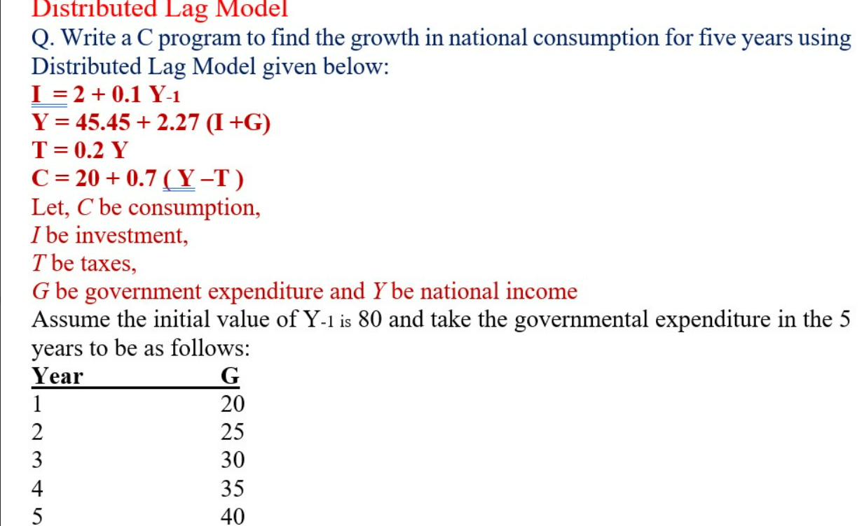
Code:
#include <stdio.h>

int main() {
// Given initial values
float Y_prev = 80;
float G[] = {20, 25, 30, 35, 40};
int num_years = sizeof(G) / sizeof(G[0]);

// Print header with better spacing
printf("-------------------------------------------------------------\n");
printf("| Year | G | Y | I | C | Growth C |\n");
printf("-------------------------------------------------------------\n");

for (int year = 1; year <= num_years; year++) {
// Calculate values
float I = 2 + 0.1 * Y_prev;
float Y = 45.45 + 2.27 * (I + G[year - 1]);
float T = 0.2 * Y;
float C = 20 + 0.7 * (Y - T);
float growth_in_consumption = C - (20 + 0.7 * (Y_prev - 0.2 * Y_prev));

// Print row with formatted values
printf("| %2d | %5.2f | %8.2f | %8.2f | %8.2f | %8.2f |\n",
year, G[year - 1], Y, I, C, growth_in_consumption);
}

// Print footer
printf("-------------------------------------------------------------\n");

return 0;
}

Output:
